Instructions for Preparation of Abstracts
- Title of Paper: The abstract title should be printed in Capitalize Each Word except preposition. Scientific names should be in italic font type. Font size: 12, Bold; Single line space (please see example).
- Author(s): Font size: 11. Use * after the presenting author.
- Affiliation: Mention the affiliation of all authors with superscript numeric marking. Only mention the email address of presenting author. (Font size: 10; single line space).
- Maximum Length: One page.
- Page Size: Executive 7.25 x 10.5 inch.
- Page Margins: 1 inch margin in all side.
- Font Size, Type and Spacing: Character fonts should be 11 in size, Calibri (Body) type and single spaced.
- Paragraphs: Paragraphs should be separated by a blank line and should not be indented.
- Figures and Tables: Figures or tables are highly recommended in the abstract. Around one fourth space of the page is recommended to allocate for figures/tables. The figures/tables should be included in camera-ready formt or JPEG format.
- Abstract Submission Dead Line: 4th February, 2023

Stratification Pattern of Dissolved Oxygen and Its impact on Scylla olivacea in the Pasur-Rupsha Estuary of Bangladesh
Muhammad Abdur Rouf^{1*}, Md. Golam Sarower¹, and Md Shahin Parvez¹
¹Fisheries and Marine Resource Technology Discipline, Khulna University, Khulna-9208, Bangladesh
*Email: roufku@yahoo.com

Stratification pattern of dissolved oxygen (DO) and associated water parameters were measured in the head of the Pasur-Rupsha Estuary of Bangladesh. Water samples were collected from two stations at 0.60 m depth intervals during high and low tides from July, 2016 to January, 2017. DO was ranged from 6.0 to 8.6 mg/l with maximum two units of variation in the profiles of the stations and demonstrated an inconsistent stratification pattern. This stratification was remarkably triggered by a relatively high concentration of DO in the bottom layer than that of the surface layer during both the high and low tides in most of the study periods. High rate of freshwater flow in the surface; existence of estuarine gravitational circulation; and lack of consumers in the bottom due to the high deposition of sediment particles were found responsible for the relatively high concentration of DO in bottom and low in surface layer of the estuary. Temperature and plankton density were found significantly (P<0.000) correlated with DO while the pH and salinity did not show any significant (P>0.3) correlation. The results explained in this study will provide considerable advances in understanding the ecosystem dynamics of the Pasur-Rupsha Estuary of Bangladesh.
Sample
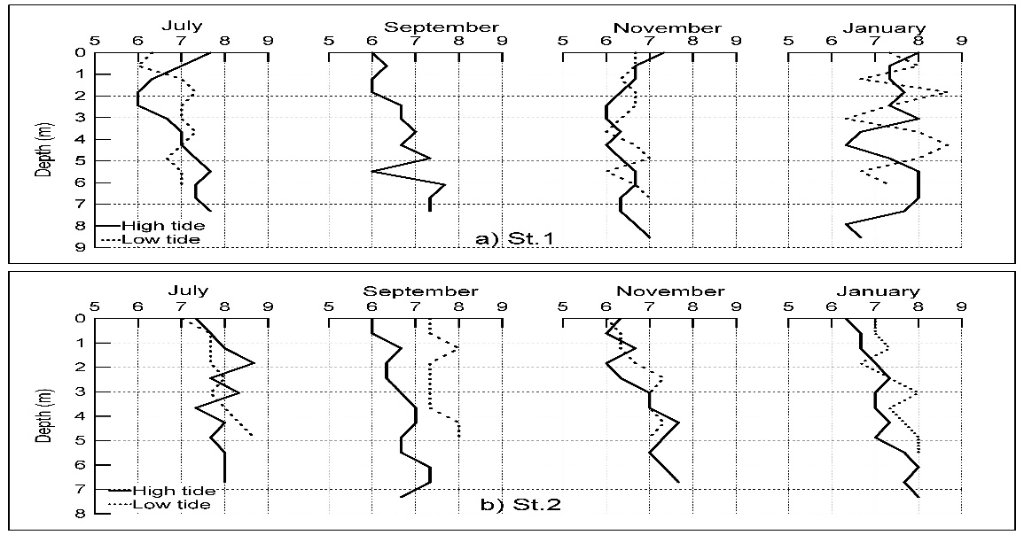Figure 1: Stratification pattern of DO in the Pasur-Rupsha Estuary

